### 

### *Reset Any User ( including root user ) Password in linux.*

Step 0 -: When System is starting press any key this Window is appear of linux version .

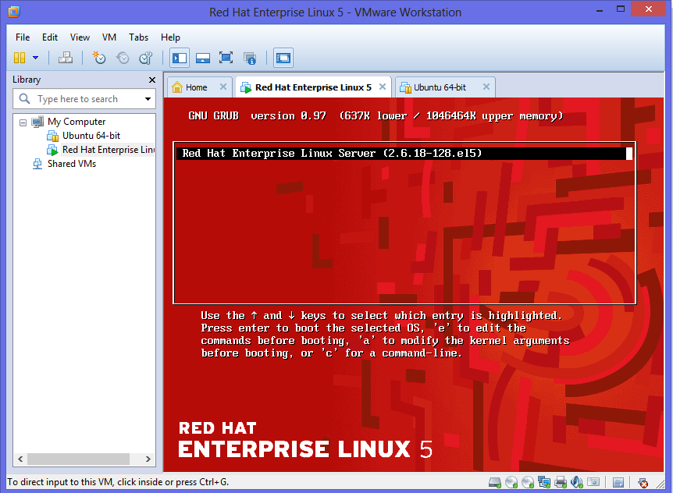

Step 1-

---> Start Rhel 4/5/6 Operating System.

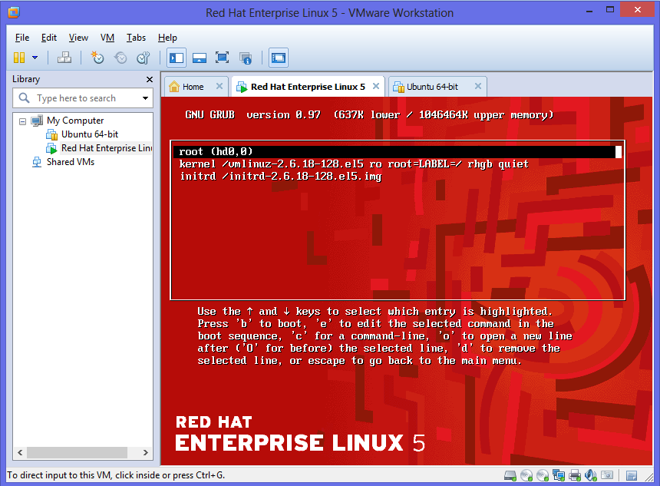

Step 2-

--> Appear GNU GRUB Option

To select which os entry is highlighted choose "e" to edit the command before booting.

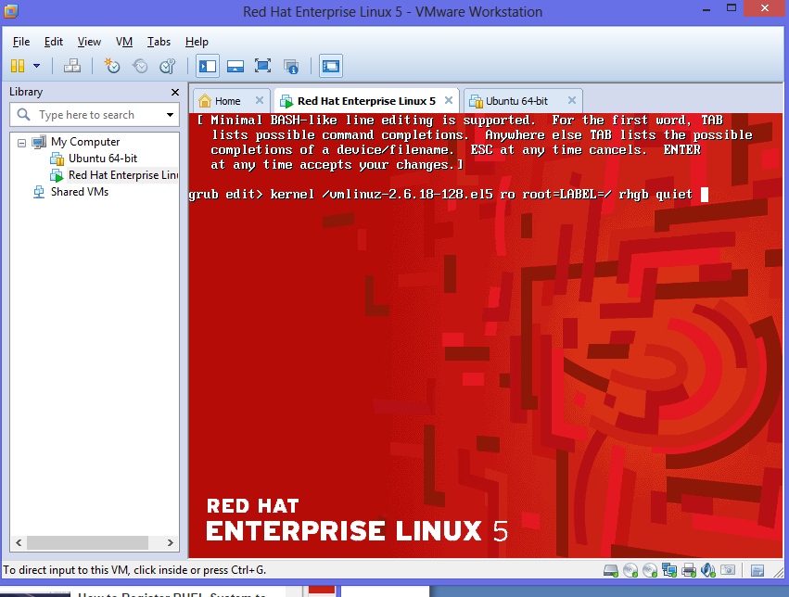

Step 3-

---> Choose Kernal Perameter setting and start the os in single user mode. Change Kernel Argument Press "e".

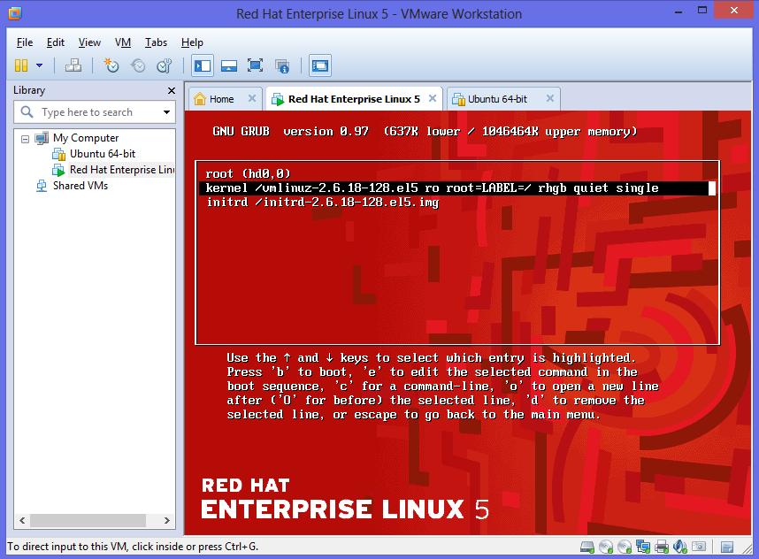

Step 4-: Boot The System Screen look like this type clear in sh-3.2# so its look good.

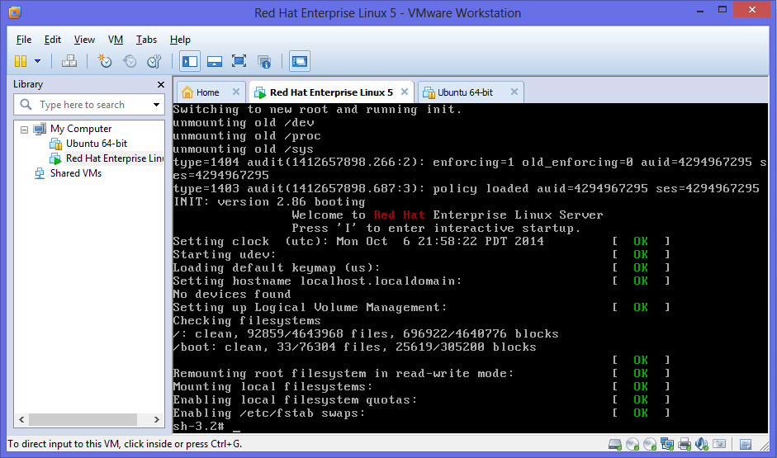

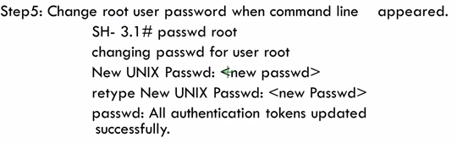

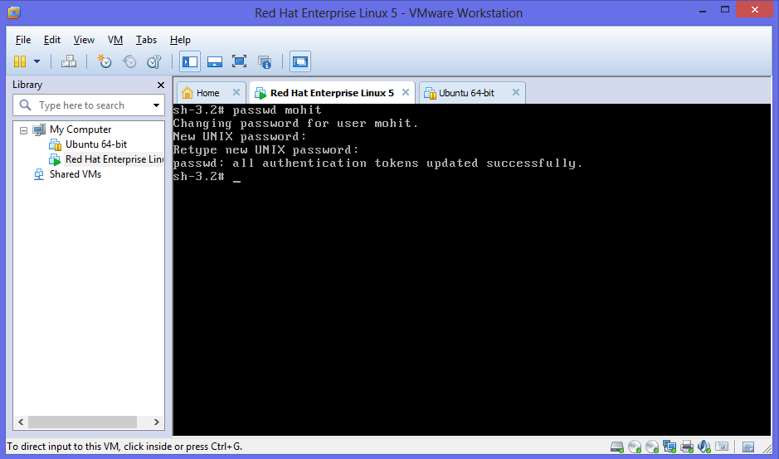

Step 6- sh-3.2# logout

